**CS398-Deep Learning**

**Homework 6**

**Lingyi Xu (lingyix2)**

1. **Choose 5-6 pictures of generated images to show how training progresses**

Epoch 0

Epoch 100

Epoch 200

Epoch 300

Epoch 400

Epoch 500

1. **A batch of real images, a batch of the gradients from an alternate class for these images, and the modified images the discriminator incorrectly classifies.**
   1. **A picture containing photo, different, wall, indoor

      Description automatically generatedA batch of real images:**
   2. **A batch of gradients from an alternate class for these images:**

* 1. **Modified images the discriminator incorrectly classifies:**

1. **Structure of CNN (from lecture slides): images maximizing the class output. One for the discriminator trained without the generator and one for the discriminator trained with the generator.**
   1. 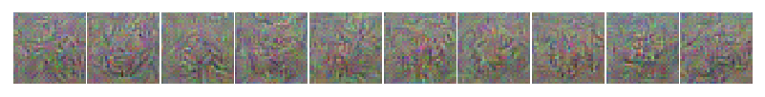**Discriminator trained without the generator**
   2. 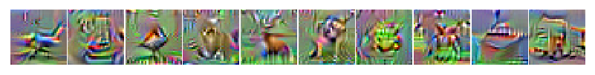**Discriminator trained with the generator**
2. **Synthetic images maximizing a particular layer of features. Do this for at least two different layers.**
   1. **Discriminator trained with the generator**
      1. **Layer 2**

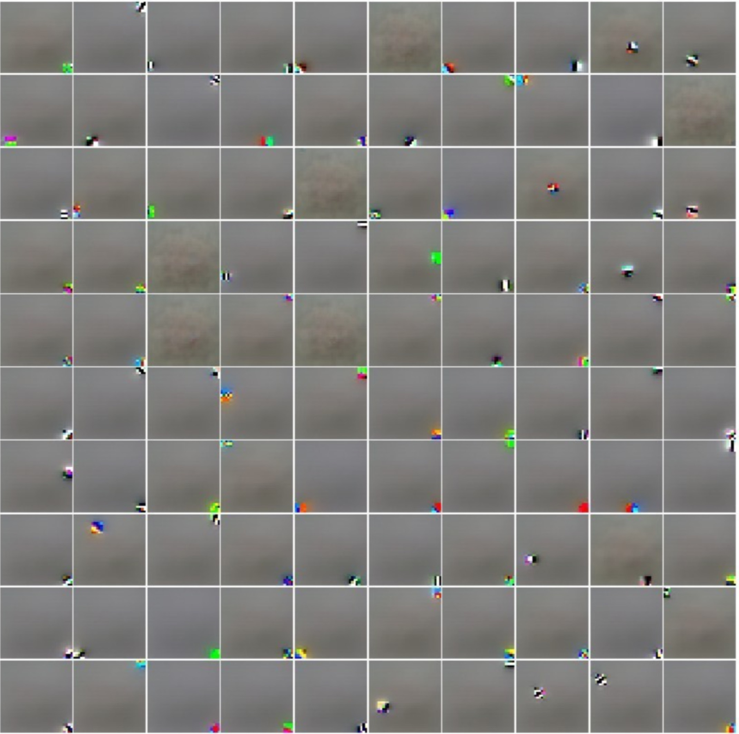

* + 1. **Layer 4**

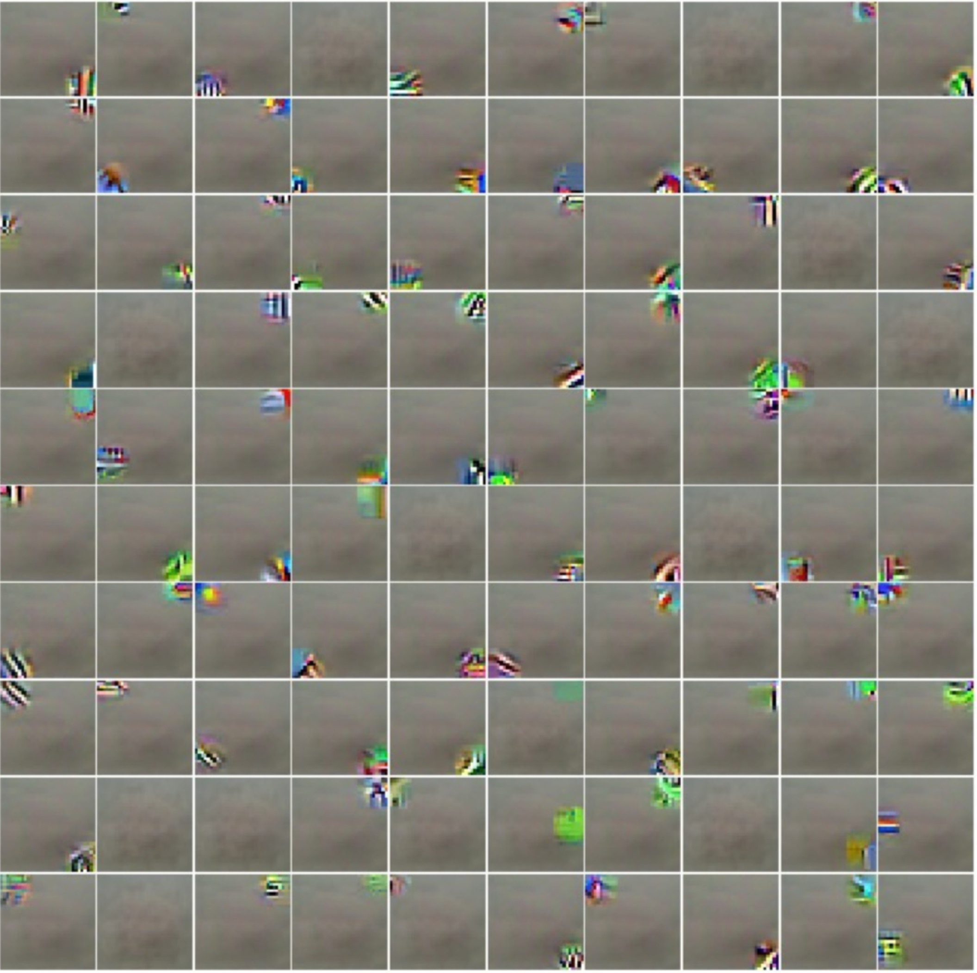

* + 1. **Layer 8**

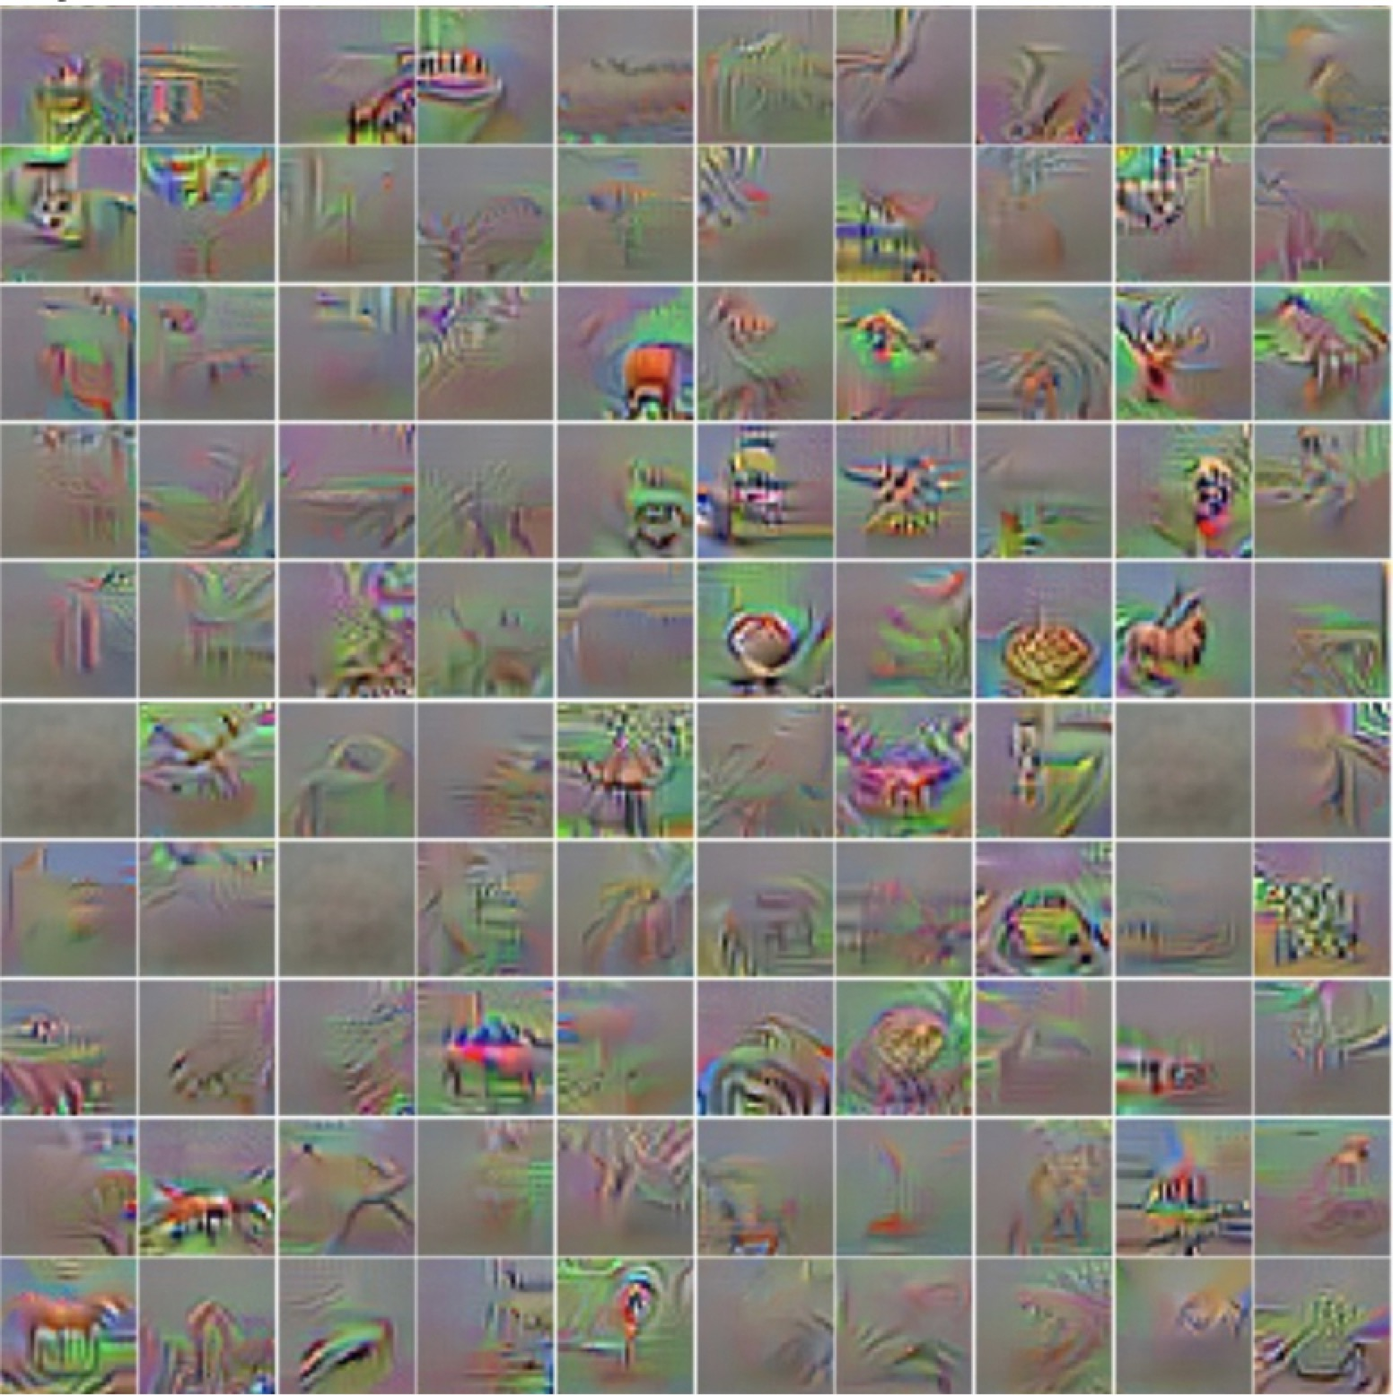

* 1. 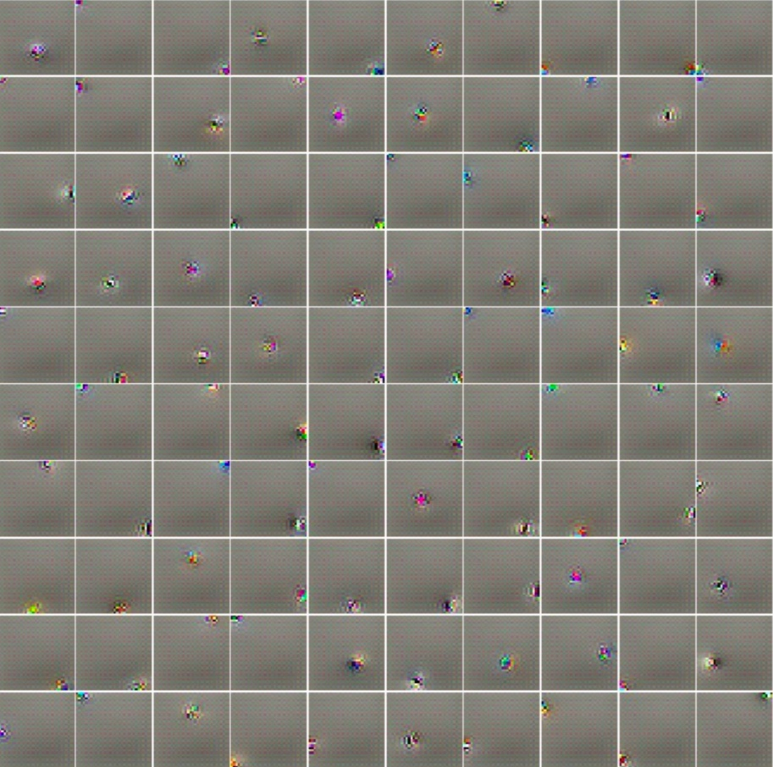**Discriminator trained without the generator**
     1. **Layer 2**
     2. **Layer 4**

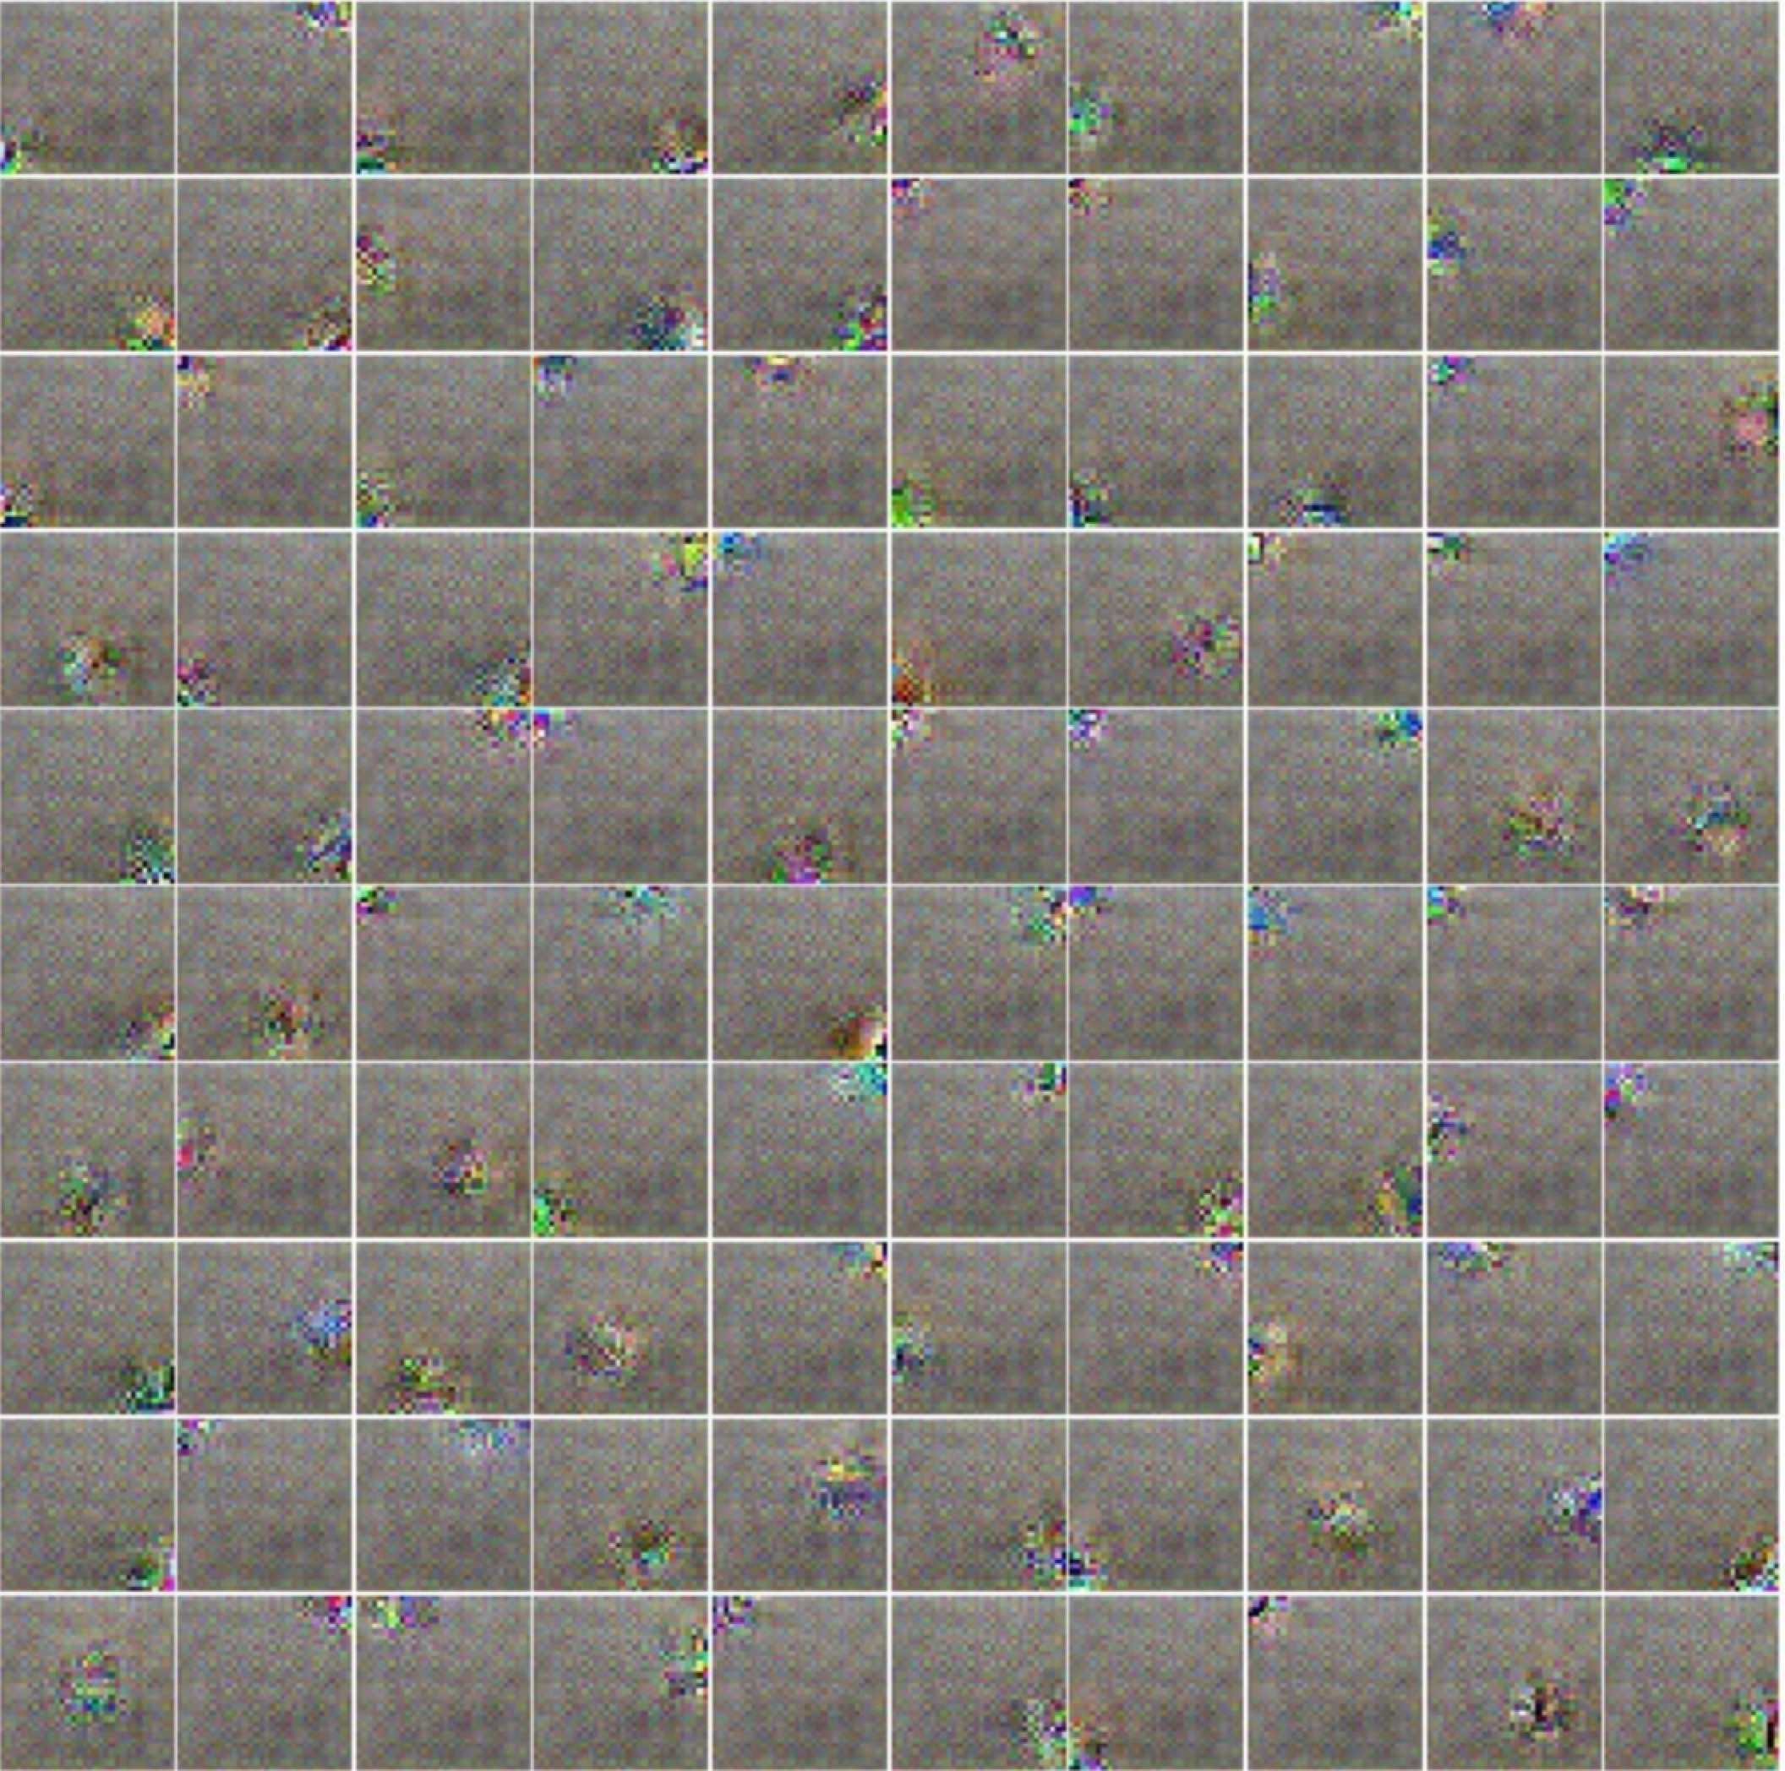

* + 1. **Layer 8**

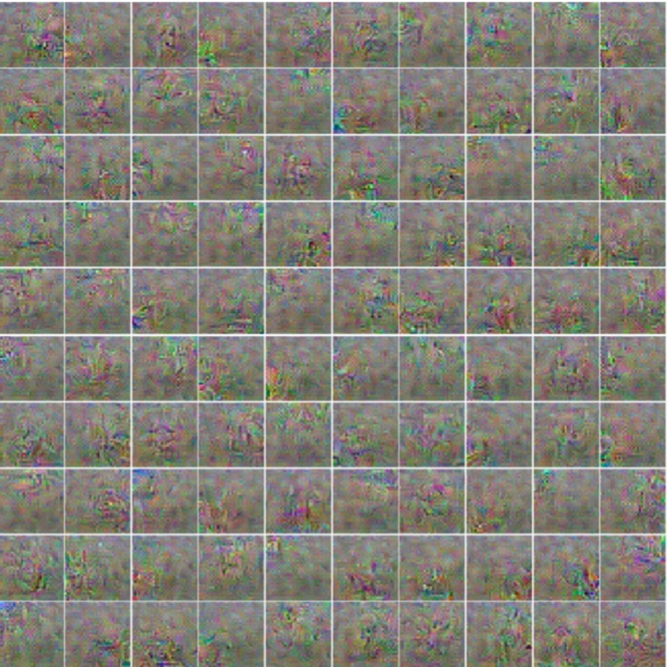

1. **Report your test accuracy for the two discriminators.**

**For the discriminator without generator, I got a test accuracy of 86.82%**

**For the discriminator with generator, I got a test accuracy of 83.76%**